# BasicSQLExportStep

**Objective:**

It executes sql query which given by user and stores the result set into output variable.  
  
**Attributes:**

|  |  |
| --- | --- |
| **Attributes** | **Description** |
| value | To enter the query to execute |
| value_type | To select type as free marker template or handlebar |
| output_variable | Used to store the response of the request |
| plugin_name | To connect with mysql server based on the plugin credentials |

**Sample config.json:**

{

"workflows":[

{

"name":"basic_sql_export",

"id":1828,

"trigger":"rest",

"expression":"/sqlexport",

"method":"GET",

"steps":[

{

"type":"start",

"id":1,

"next":{

"start":"2"

}

},

{

"id": "2",

"type": "basicsql-export",

"value":"select * from test",

"value_type": "hb",

"output_variable": "result",

"plugin_name": "user_mysql",

"next":{

"success": "3",

"failure": "hangup"

}

},

{

"variable_name":"result",

"http_response_code":"200",

"response_content_type":"application/json",

"value_type":"hb",

"type":"send",

"id":"3",

"next":{

"success":"hangup",

"failure":"hangup"

}

}

]

}

],

"filters":[],

"server":{},

"plugins":[

{

"id": 243,

"name": "user_mysql",

"type": "mysql-plugin",

"version": "1.0",

"category": "Database",

"server": "localhost",

"username": "root",

"password": "root",

"schema": "testDB"

}

]

}

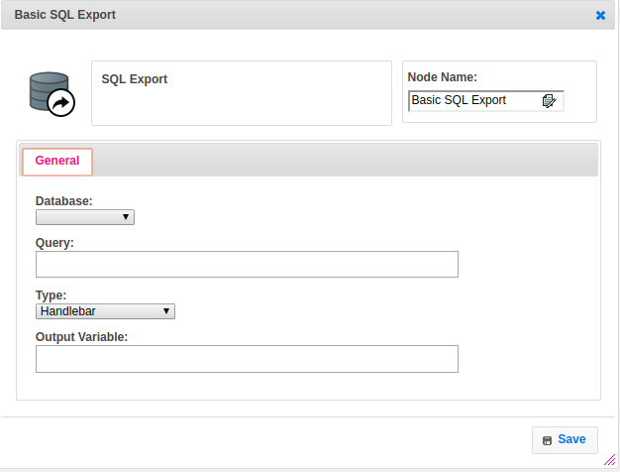

**Executor Description:**

* In executor class first it executes sql query which given by user based on the plugin credentials it hits the respective database.
* Print the records in stringwriter by using csvprinter.
* Then stores the result set in output